STOCK CONTROL

SELİN AKGÜN

201835008

2021

#### STOCK CONTROL

What is stock control?

Stock control, also known as [**inventory control**](https://www.unleashedsoftware.com/inventory-management-guide/inventory-control), is the process of maintaining the appropriate quantity of stock, so a business can meet customer demand without delay while keeping the costs of holding stock to a minimum.

Businesses dealing with physical products need stock to sell. The purpose of stock control is to make sure the business always has enough stock for their customers, while balancing the amount spent on acquiring and storing stock. Though this might seem simple in theory, it can involve factors outside of the business’ control such as the weather, economic downturns, union action and more.

Stock control is important because it can be the difference between loss and profit. Done right, it keeps costs down while increasing your profitability on every sale.

What are the methods of stock control?

There are many stock control methods, including:

* Just-in-time (JIT)
* FIFO
* Economic Order Quantity
* Vendor-managed inventory
* Batch control

Regardless of which method you use, you need to have a stock control system in place.

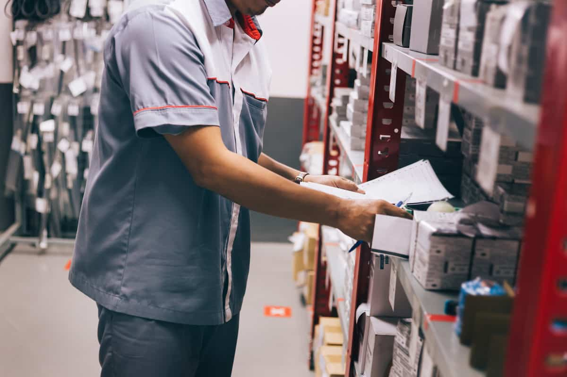

Features of a stock control system

An automated inventory control system helps businesses maintain a competitive edge and maximises productivity. An automated system should:

* **Support real-time, perpetual inventory tracking.** This means keeping track of inventory as it moves; you don’t want to run your business using outdated stock figures as it can harm your [**supply chain**](https://www.unleashedsoftware.com/blog/important-role-inventory-management-supply-chain)
* **Support sales and shipping.** You’ll want a system that can generate fulfilment documentation such as picking and packing notes, and invoices
* **Support procurement.** Features such as automated reordering and supplier price lists reduce friction in the purchasing process
* **Integrate with other programs.** If you’re looking for maximum efficiency and accuracy, make sure your chosen system integrates with your CRM, ERP, accounting or other management systems
* **Generate useful reports.**Important [**types of inventory reports**](https://www.unleashedsoftware.com/inventory-management-guide/types-of-inventory-reports) include inventory summaries and totals, transaction reports and order history

# **How to Design an Inventory Control System**

The purpose of an inventory control system is twofold. The primary function is to ensure that a small business meets customer needs -- that products are available when customers want them. But proper inventory control can also help maximize profits for a small-business owner, while reducing potential theft and loss. Large firms, such as Walmart, maximize profits by using supply-chain or just-in-time inventory-control methods. Small businesses can use a mix of technology, proper accounting and effective operations to ensure inventory is always available for customers while avoiding costly overstock problems.

#### 1

Determine your customer needs -- that is, how much product are your customers buying, and how much do you expect them to buy in the near and distant future? Use a method called "forecasting" to determine what your customers are likely to buy in the next day, week, month and year, based on what they bought in the previous 12 months. Since forecasts are never 100 percent accurate, plan to have an amount of "safety" inventory on hand to cover potential shortages. You can also plan to include a safety lead time that will let you have inventory delivered quickly to meet increased customer demand if the supplier is close enough -- or the delivery system is quick enough -- to allow for that method.

#### 2

Based on customer needs you have forecast, establish an approved stock list for each warehouse you use. Determine whether you will warehouse the inventory at your business or use companies that specialize in holding and shipping inventory. Small businesses often order unnecessary stock that sits dormant in the warehouse. This increases your costs and decreases your profits. Before adding inventory, obtain a customer commitment to purchase particular items. Use drop shippers -- who will warehouse items and deliver them directly to customers without shipping them to your business -- as a means of reducing inventory-holding costs. Reduce potential theft by restricting access to your warehouses to employees directly involved in moving the merchandise.

#### 3

Determine the method of inventory management you will use. The first, in-first-out -- or FIFO -- method involves selling the oldest items, or those products that have been in the warehouse the longest, first. In an inflationary period, FIFO will lead to higher profits, since you are selling goods that theoretically cost you less when you purchased them at current, inflated, prices. Of course, the effect would be the opposite in a deflationary period. Using the last-in, first-out -- or LIFO -- method would be desirable if the items you received more recently are perishable or time-sensitive. Use weighted average if you have relatively few items to sell. In this method, you recalculate the cost of your entire remaining inventory every time you sell one item.

#### 4

Keep track of the exact number and cost of items you have on hand, including how much inventory comes in and goes out daily. Do this by hand if you have a relatively small amount of items in your inventory. But for most inventory counts, use available technology to help track inventory. For example, barcode printers can create labels that list product numbers you can then attach to each item. Barcode scanners let you quickly scan the product item numbers, while small handheld computers let workers quickly input inventory information. The information is then transmitted to a computer, where inventory-control software tracks the disposition of each inventory item.

## 1. Overview

Stock control, otherwise known as inventory control, is used to show how much stock you have at any one time and how you keep track of it.

It applies to every item you use to produce a product or service, from raw materials to finished goods. It covers stock at every stage of the production process, from purchase and delivery to using and re-ordering the stock.

* Stock Controller responsibilities include:
* Forecasting supply and demand to prevent overstocking and running out-of-stock (OOS)
* Submitting purchase details (vendors information, invoices and pricing) to internal databases
* Placing orders to replenish merchandise as needed



## Job brief

We are looking for a Stock Controller to manage our inventory and purchase merchandise based on our company’s needs.

Stock Controller responsibilities include tracking shipments, overseeing inventory audits and maintaining reports of purchases and pricing. To be successful in this role, you should be familiar with supply chain procedures and have good communication skills to interact with vendors, clients and internal teams.

## Responsibilities

* Forecast supply and demand to prevent overstocking and running out-of-stock (OOS)
* Enter purchase details (vendors information, invoices and pricing) into internal databases
* Place orders to replenish merchandise as needed
* Track shipments and address any delays
* Oversee storage of products, particularly of fragile items
* Evaluate suppliers’ offers and negotiate profitable deals
* Coordinate regular inventory audits

## Requirements

* Proven work experience as a Stock Controller, [Inventory Manager](https://resources.workable.com/inventory-manager-job-description) or similar role
* Good understanding of supply chain procedures
* Working knowledge of inventory management software (e.g. NetSuite or TradeGecko)
* Active participation in inventory audits
* Excellent organization skills
* Good communication and negotiation abilities
* BSc in Logistics, Business Administration or relevant field

## What is an inventory management system ?

Inventory represents one of a business’s most important assets, since inventory turnover is a primary means of revenue generation and earnings for a company’s shareholders For a company, inventories are goods that are purchased, processed or sold at some point in time.  
The two basic parameters of inventory management models are dateand quantity ordered. We can therefore order fixed date or variable, and fixed or variable quantity.  
Inventory Management Software is a system that allows the user to manage and track inventory levels, orders, sales and deliveries. It is also used in the industry to create a work order and other documents related to production. It prevents overstocking and product failures.

Here is an example data model of inventory management system :[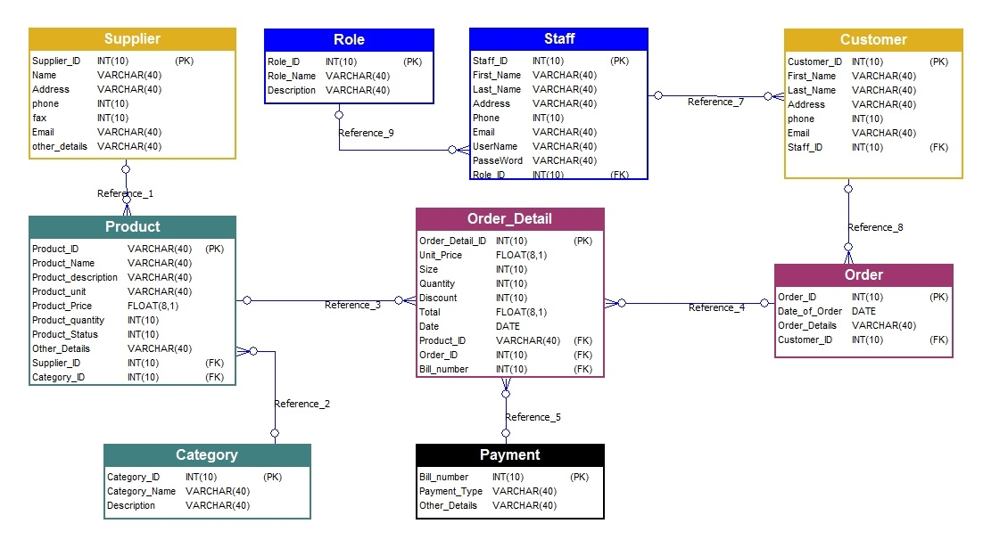](https://soft-builder.com/wp-content/uploads/2020/06/inventory-system-er-diagram.jpg)

* Staff has role
* Staff registers customers
* Customer makes order
* Order has Order details
* Product belongs to category
* Supplier supplies product

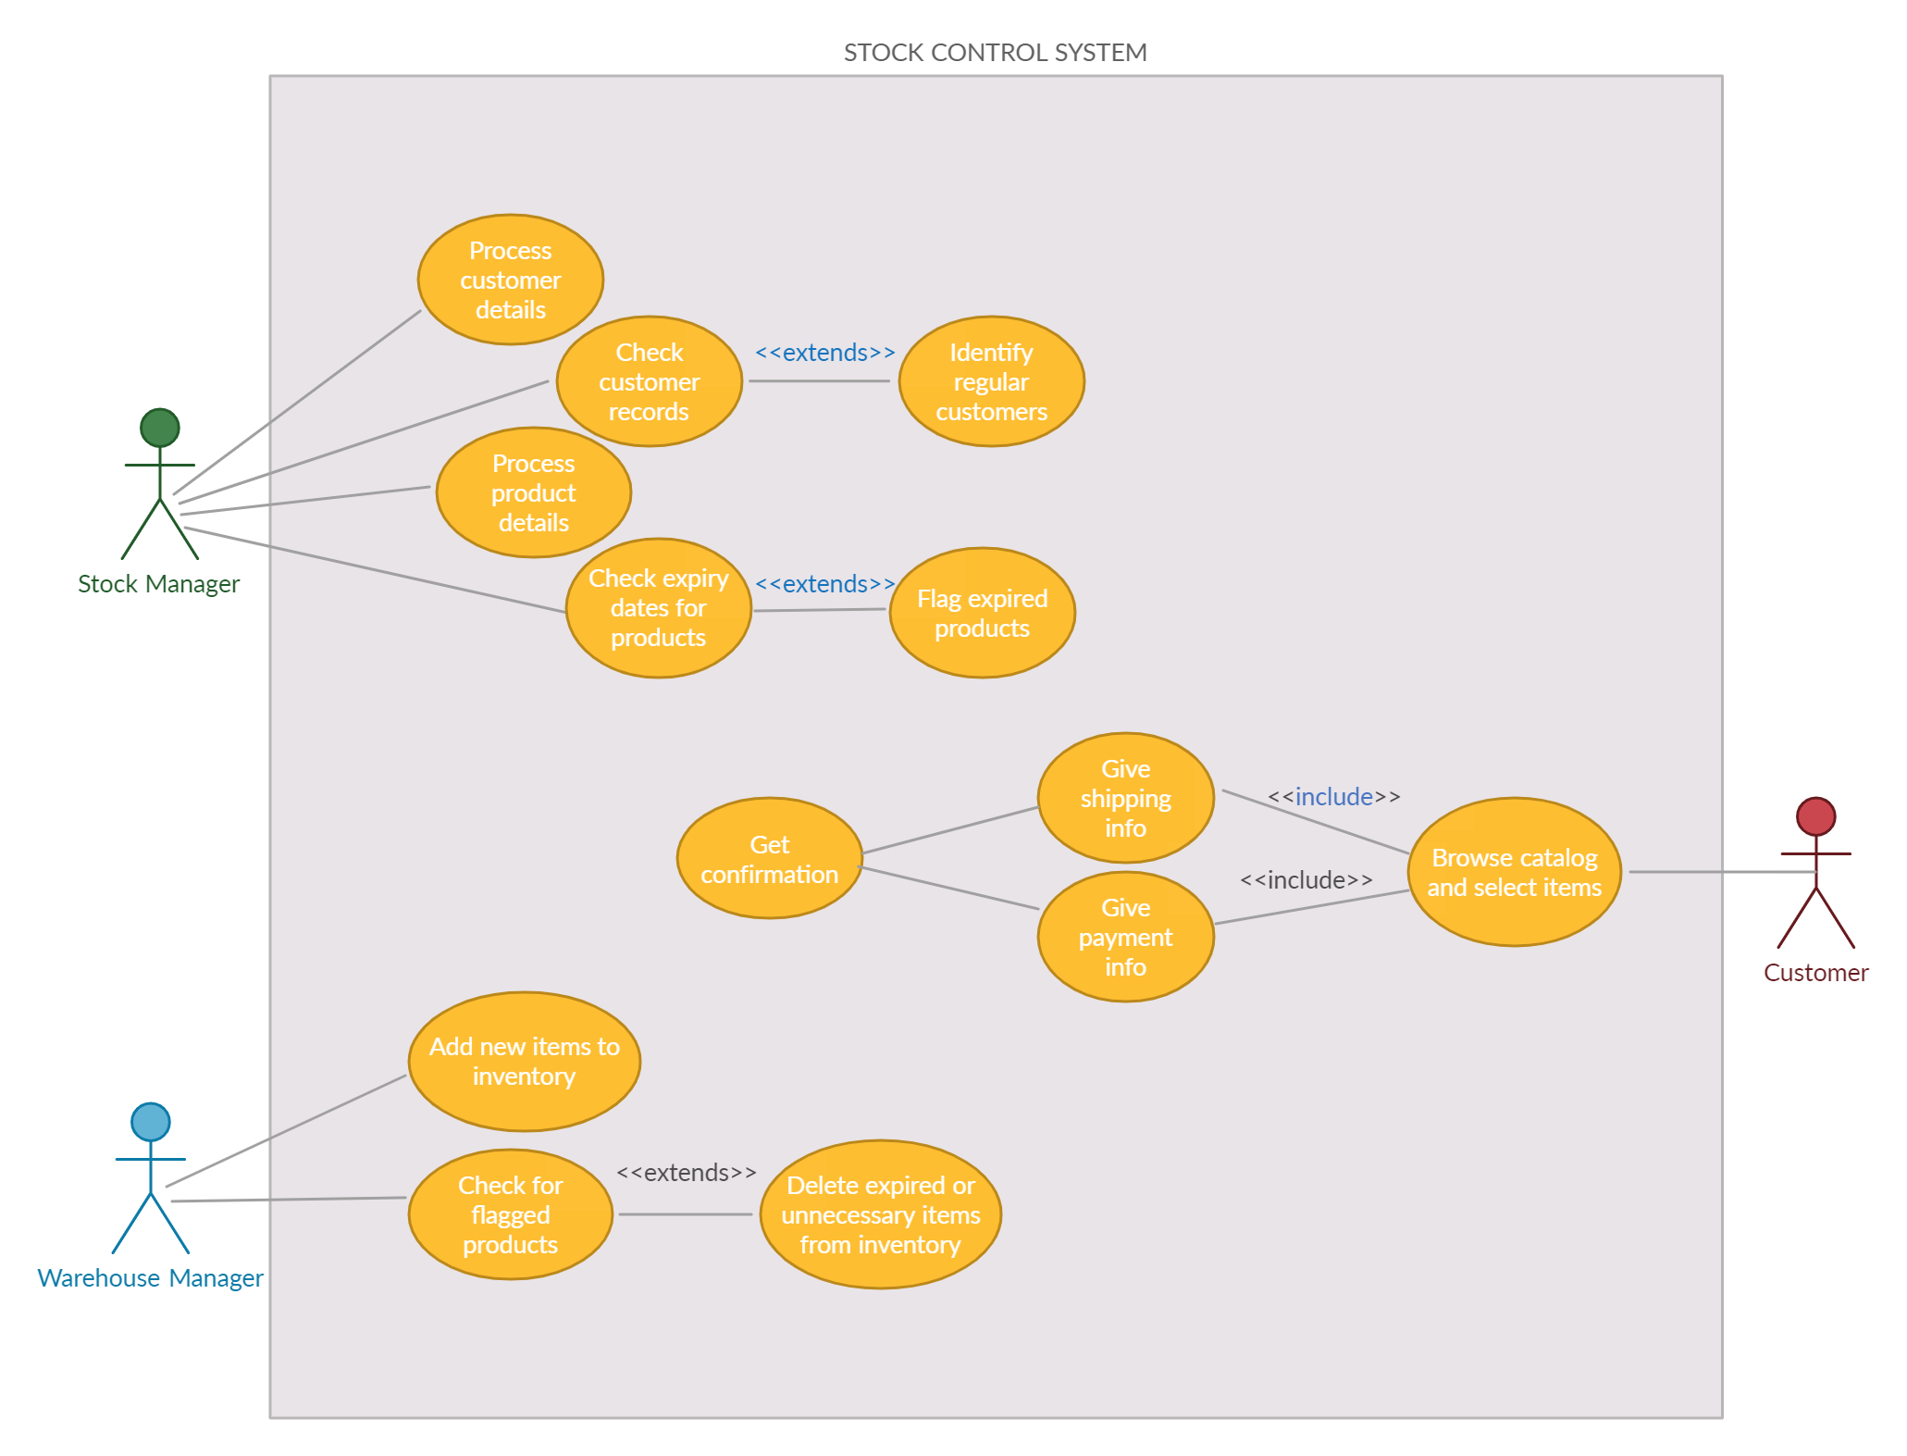

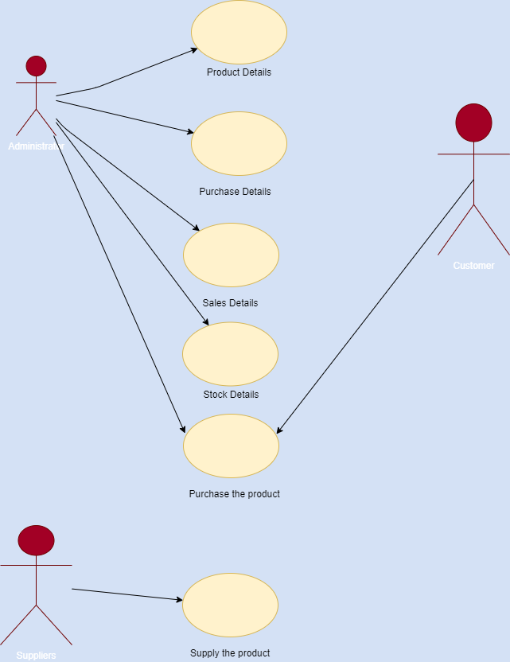

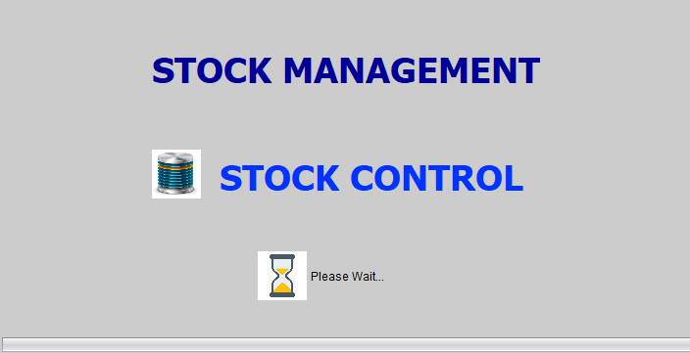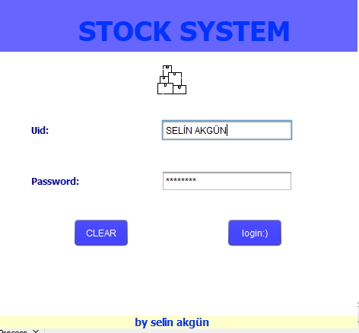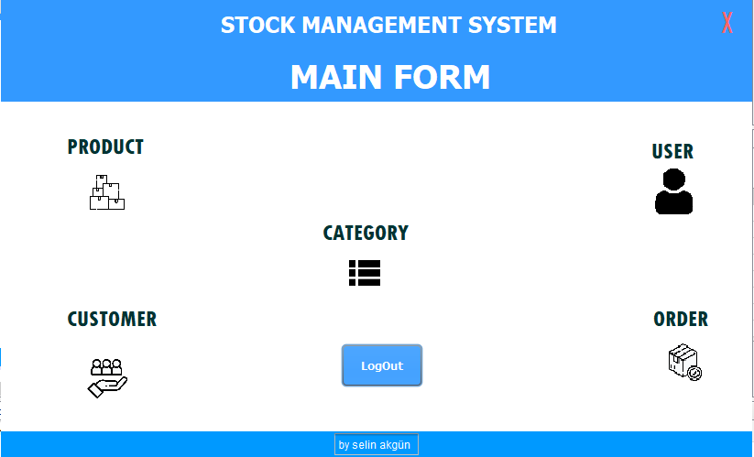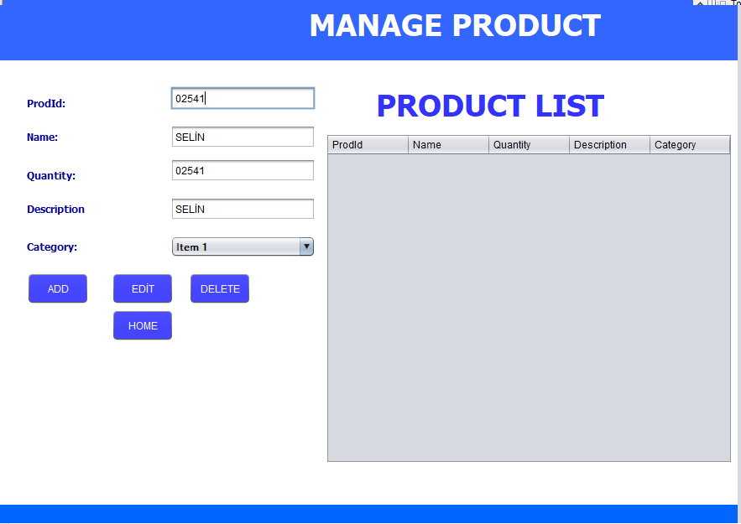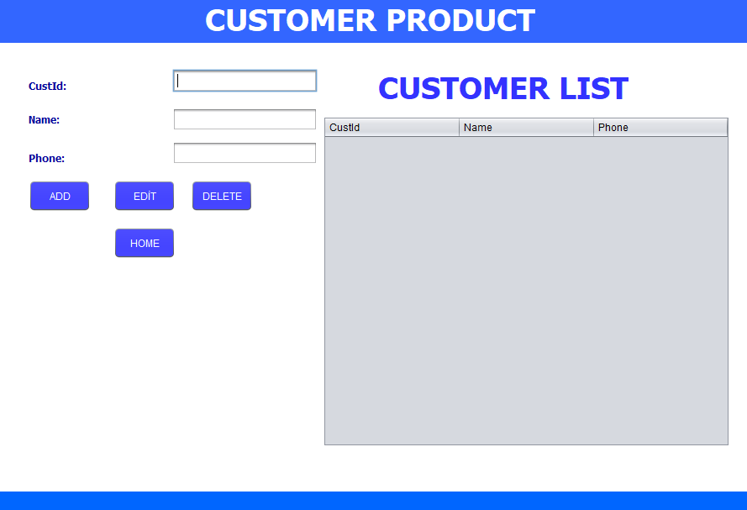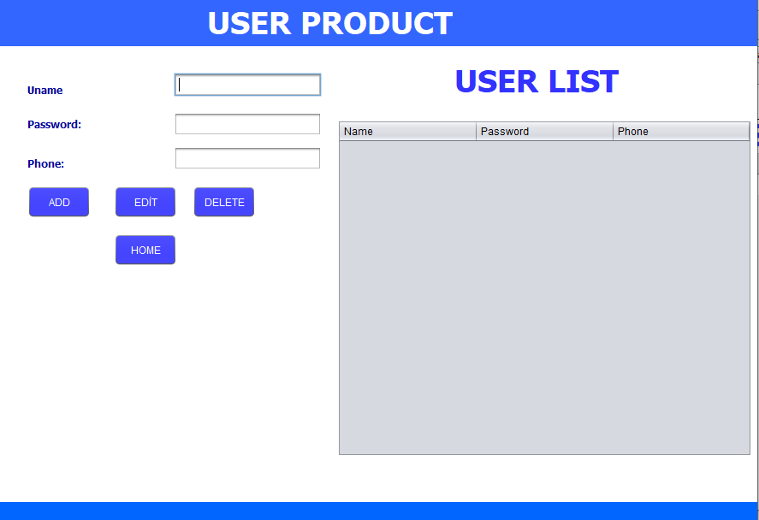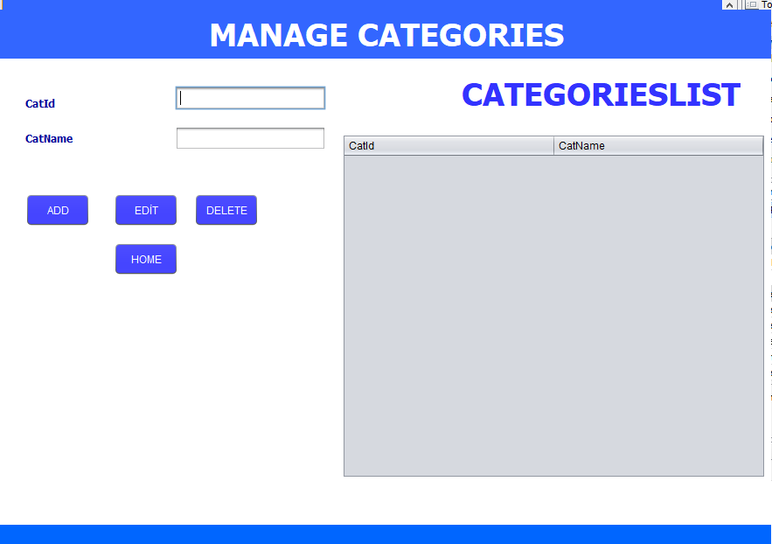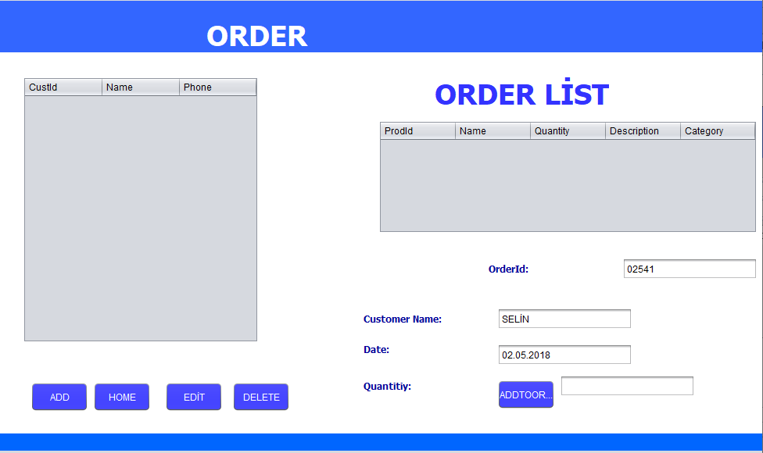

**source**

<https://www.unleashedsoftware.com/blog/five-basics-stock-control>

<https://www.infoentrepreneurs.org/en/guides/stock-control-and-inventory/>

<https://www.bgateway.com/resources/stock-control>

<https://www.bgateway.com/resources/stock-control#:~:text=Overview,raw%20materials%20to%20finished%20goods>.

<https://www.betterteam.com/stock-controller-job-description>

https://app.creately.com/diagram/GYTHfoqu8hq/edit